***Business Reason***

The Revenue row in the Financial Values table should match the total estimated amount for the proposed price in the Monthly Totals table. Pricing should be accurate and consistent across and within quotes so sales people can provide quality quotes and have a good experience using Capture.

***Task Requirements***

The Revenue row (Total column) in the Financial Values table should match the Total Estimated Amount for the Proposed Price. The values should match even if you have one, none, or some of the fees (admin fee, frf, erf).

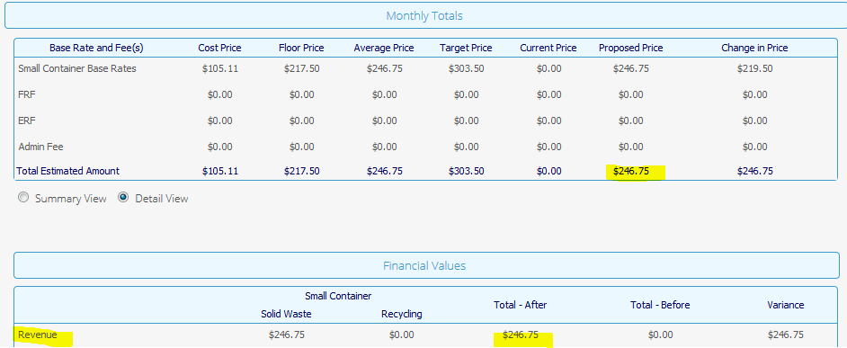

***Build Plan***

1. The frf and erf on admin fee were being incorrectly added to the total.
2. The Financial Values tables are two html attributes financialSummaryView_html_quote and financialDetailView_html_quote.
3. These attributes are set to their defaults. Their defaults are set in 2 commerce libraries “Financial Detail View” and “Financial Summary View.”
4. “Financial Summary View”
   1. The adminERFandFRFPerCol was being added to the total even though the total price already included the fees. The solution was to comment out the addition of the adminERFAndFRFPerCol on lines 76 and 80.
   2. Search for “SR 3-9476835591” in the code to find the comments.
5. “Financial Detail View”
   1. Follow the same process as for the summary view. Commented out the addition of “adminERFAndFRFPerCol”
   2. Search for “SR 3-9476835591” in the code to find the comments.

Unit Test

1. Open quote A146809 in dev
2. Select all possible combinations of erf, frf, and admin fee and for each combination compare the revenue row of the Financial Values table (column Total) to the total estimated amount of the Monthly Totals table (column Proposed Price).
   1. Each time you change fees, click “Recalculate Fees”
3. Do this for both the detail and the summary views.

***Admin Guide Changes***

The adminERFAndFRFPerCol value is no longer added to the totals for the detail and summary financial views. This code is kept in “Financial Summary View” and the “Financial Detail View” commerce libraries.

***User Guide Changes***

None.